10/27/2024

FOLAMI OLUWASEUN SON OF GRACE.

JOD DATA GROUP.

**MEDICAL INSURANCE COST PREDICTOR PROJECT DOCUMENTATION**

## **Table of Contents………..**

1. **Introduction**
   * **Overview of the Project**
   * **Importance of Medical Insurance Prediction**
   * **Project Objectives**
2. **Project Goals and Audience**
   * **Define Specific Goals**
   * **Identify Target Audience**
3. **Dataset Description**
   * **Source of the Dataset**
   * **Features of the Dataset**
   * **Data Preprocessing** Steps.
4. **Exploratory Data Analysis**

**. Briefly describe the initial data examination to understand distributions, relationships, and patterns.**

1. **Data Visualization**

**. Briefly describe the initial data examination to understand distributions, relationships, and patterns.**

1. **Machine Learning Models**
   * **Overview of Selected Models**
   * **Model Training and Evaluation Process**
   * **Hyperparameter Tuning**
2. **Feature Engineering**
   * **Explanation of Feature Selection**
   * **Handling Categorical Variables**
3. **Model Deployment**
   * **Steps for Deploying the Model**
   * **Tools Used for Deployment**
4. **User Interface**
   * **Description of the Web Application**
   * **Frontend Technologies Used**
5. **Testing and Validation**
   * **Methods of Testing the Application**
   * **Validation of Model Performance**
6. **Challenges Faced**
   * **Technical Challenges**
   * **Solutions Implemented**
7. **Future Work**
   * **Potential Improvements**
   * **Expansion of the Project**
8. **Conclusion**
   * **Summary of Findings**
   * **Final Thoughts**
9. **References**
   * **Cite All Resources and Literature Used in the Project.**

### ****Introduction****

#### **Overview of the Project**

The **Medical Insurance Cost Prediction Project** is designed to predict individual medical insurance premiums based on demographic and lifestyle-related features using machine learning models. Accurate insurance cost prediction is critical for insurance companies, individuals, and healthcare providers alike, as it impacts financial planning, risk assessment, and policy pricing strategies. This project combines data-driven insights and predictive modeling techniques to determine how factors such as age, gender, BMI, smoking status, number of dependents, and geographical region contribute to an individual’s insurance costs.

By leveraging a structured approach, the project integrates data preprocessing, exploratory data analysis, feature engineering, model training, evaluation, and deployment to build a reliable and interpretable prediction model. The end product is a web application where users can enter relevant information and receive a real-time insurance cost estimate based on their inputs. The model’s predictions can be useful for individuals seeking personalized insights into their insurance costs and for insurance companies interested in refining their pricing models.

#### **Importance of Medical Insurance Prediction**

Medical insurance prediction plays a significant role in the healthcare and insurance sectors due to its potential to enhance decision-making for both providers and consumers. Here are several reasons why accurate prediction of insurance costs is important:

1. **Financial Planning and Cost Transparency**  
   For individuals, predicting insurance costs allows for improved financial planning, enabling them to better prepare for healthcare expenses. As healthcare costs rise, a clear understanding of anticipated insurance premiums helps families and individuals make informed decisions about their coverage options and budgeting.
2. **Risk Management for Insurance Providers**  
   Insurance companies rely on accurate cost predictions to assess risk levels and set appropriate premiums for their clients. By understanding the factors that contribute to higher or lower medical costs, insurers can optimize premium pricing, manage financial risk, and improve the overall sustainability of their services.
3. **Enhanced Customer Experience Through Personalization**  
   Predictive modeling empowers insurance companies to offer tailored insurance quotes based on a client's health and lifestyle profile. This level of customization enhances the customer experience by ensuring that clients receive fair and personalized insurance quotes, which in turn increases client satisfaction and loyalty.
4. **Data-Driven Public Health Insights**  
   Insurance data often reveals broader health trends in populations. Through predictive analytics, insights can be derived that inform public health initiatives aimed at reducing costs. For example, understanding the role of smoking, BMI, and age on medical costs may encourage policies that promote healthier lifestyles and contribute to overall health improvement.
5. **Healthcare Equity**  
   Identifying demographic patterns in insurance costs can help policymakers and healthcare providers address disparities in healthcare accessibility and affordability. Predictive analysis allows for proactive measures to ensure that all individuals, regardless of their demographic background, have access to affordable healthcare coverage.

#### **Project Objectives**

The main objectives of the Medical Insurance Cost Prediction Project are as follows:

1. **Develop an Accurate Predictive Model**  
   To build and deploy a machine learning model that accurately predicts an individual’s medical insurance cost based on various features such as age, BMI, smoking status, number of dependents, gender, and region. The model’s accuracy and robustness are prioritized to ensure that it provides reliable and actionable predictions.
2. **Understand Key Cost-Influencing Factors**  
   To analyze and quantify the relationship between insurance cost and its influencing factors. This objective includes identifying how each feature impacts the predicted cost, thereby increasing interpretability for users and helping insurance companies make data-driven pricing decisions.
3. **Data Cleaning and Preprocessing**  
   To ensure that the dataset is preprocessed thoroughly, addressing any missing values, normalizing numerical data, and encoding categorical features as needed. High-quality data preparation is essential to model performance and lays the groundwork for accurate predictions.
4. **Perform Exploratory Data Analysis (EDA)**  
   To conduct a comprehensive exploratory analysis to identify key trends, patterns, and correlations within the dataset. EDA enables a better understanding of the data distribution, which informs model selection and feature engineering.
5. **Compare Multiple Machine Learning Models**  
   To evaluate the performance of several machine learning models, such as Linear Regression, Random Forest, and Gradient Boosting, in order to identify the most suitable model. Model performance is assessed using established metrics, with a focus on accuracy, interpretability, and generalizability.
6. **Optimize Model Through Hyperparameter Tuning**  
   To enhance the chosen model’s accuracy and prevent overfitting by using hyperparameter tuning and cross-validation techniques. The goal is to create a model that generalizes well to unseen data and provides consistent predictions.
7. **Deploy the Model via a Web Application**  
   To develop a user-friendly web application where users can input relevant data and receive instant predictions for their medical insurance costs. The deployment will involve integrating the trained model with a web framework, allowing for accessible and scalable predictions.
8. **Provide Thorough Documentation and Future Directions**  
   To document each phase of the project in detail, including data exploration, model development, evaluation, and deployment processes. The documentation serves as a resource for both current and future users, with recommendations for model improvements and new features.

This introduction gives a well-rounded view of the project’s goals, the significance of accurate insurance predictions, and the strategic objectives for delivering an effective and impactful solution.

### ****Project Goals and Audience****

#### **Define Specific Goals**

The Medical Insurance Cost Prediction Project is structured around several specific, measurable goals to ensure its effectiveness and usability. Each goal aligns with the broader objectives of accuracy, usability, and real-world applicability. The specific goals include:

1. **Develop an Accurate Predictive Model**  
   Build a predictive model that reliably estimates medical insurance costs based on user-input features like age, gender, BMI, smoker status, number of dependents, and region. The model aims to achieve a high level of accuracy and low error rates, as measured by mean squared error (MSE), root mean squared error (RMSE), and R² score. By focusing on accuracy, the project ensures that its predictions provide value to users by closely aligning with expected insurance costs.
2. **Optimize Model Interpretability**  
   Not only should the model be accurate, but it must also be interpretable. This means clarifying how individual features contribute to cost predictions, allowing users to understand which factors impact their premiums the most. This transparency builds user trust and helps insurance companies in adjusting their pricing strategies.
3. **Implement a Scalable and User-Friendly Application**  
   Develop a web application that seamlessly integrates the model into an intuitive interface, making it accessible to users regardless of technical background. This application should handle user inputs, compute predictions in real-time, and present them in a clear, understandable format. Additionally, the app should be scalable, able to handle numerous requests simultaneously.
4. **Enhance Data Quality Through Comprehensive Preprocessing**  
   Use detailed data preprocessing techniques to address any data quality issues such as missing values, imbalanced classes, or skewed distributions. This goal is essential to ensure that the model is trained on high-quality data, leading to more robust predictions.
5. **Evaluate and Compare Multiple Models for Robustness**  
   Train and test multiple machine learning models, such as Linear Regression, Random Forest, and Gradient Boosting, to identify the best-performing model. By comparing different models, this project aims to balance accuracy, interpretability, and computational efficiency.
6. **Create Comprehensive Documentation for Future Development**  
   Document every stage of the project, including data exploration, feature engineering, model development, and deployment. This documentation is intended to serve as a resource for stakeholders, developers, and researchers interested in replicating, modifying, or extending the project.

#### **Identify Target Audience**

The target audience for this project includes various groups, each of whom may benefit from the insights and predictions generated by the model. The target users include:

1. **Insurance Companies and Underwriters**  
   For insurance providers, this project can assist in pricing policies more accurately by identifying the risk factors associated with higher insurance costs. Underwriters can use these insights to structure premiums in a way that reflects the risk profile of individual clients, thus improving the financial sustainability of insurance offerings.
2. **Individuals and Policyholders**  
   For individuals considering medical insurance, this application offers a tool for estimating potential insurance costs based on personal factors. Policyholders can input their data to gain an understanding of how their profile affects premiums, which can assist in financial planning, decision-making, and exploring ways to reduce premiums (e.g., through lifestyle changes).
3. **Healthcare and Public Health Organizations**  
   Healthcare providers, policymakers, and public health professionals can gain insights into how various demographic and lifestyle factors influence medical costs. By understanding these patterns, they can better address healthcare disparities, improve resource allocation, and promote initiatives that reduce healthcare costs for high-risk groups.
4. **Data Scientists and Machine Learning Practitioners**  
   Data scientists and machine learning enthusiasts interested in healthcare analytics, insurance technology, and predictive modeling may find value in this project. With detailed documentation, preprocessing methods, model comparisons, and deployment strategies, the project serves as a comprehensive case study for those learning or working in this domain.
5. **Academic and Research Institutions**  
   Universities and research institutions focused on actuarial science, health economics, or data analytics may use this project as a teaching tool or research reference. By exploring the model and techniques used, students and researchers can learn about real-world applications of machine learning in the insurance and healthcare fields.

This section helps establish the relevance of the project for each audience, framing the goals to address their unique needs and expectations.

### ****Dataset Description****

#### **Source of the Dataset**

The dataset used for this project is a comprehensive collection of anonymized medical insurance records. It includes various demographic, health-related, and regional factors that contribute to an individual's insurance premium costs. Typically, this dataset can be sourced from open data repositories like Kaggle, government databases, or insurance company anonymized data (if available for research purposes). For this project, we used the **Medical Insurance Cost Dataset** from Kaggle, which includes detailed records of over 2,772 individuals from different regions in India.

The data was curated for machine learning purposes and has been widely used in similar projects focused on insurance cost prediction, making it a reliable source for this analysis.

#### **Features of the Dataset**

The dataset contains the following key features:

1. **Age**: The age of the individual (continuous, in years).
2. **Sex**: The gender of the individual (categorical, male or female).
3. **BMI (Body Mass Index)**: A measure of body fat based on height and weight (continuous). BMI is an important predictor, as it correlates with health risk factors that impact insurance costs.
4. **Children**: The number of children/dependents the individual has (integer).
5. **Smoker**: A binary variable indicating smoking status (yes or no). Smoking status is often correlated with higher insurance costs due to associated health risks.
6. **Region**: The residential region of the individual in the United States (categorical, one of four regions: northeast, northwest, southeast, southwest).
7. **Charges**: The annual medical insurance premium (continuous). This is the target variable we aim to predict, representing the actual insurance cost for each individual.

These features collectively provide valuable insights into the variables influencing medical insurance costs, allowing us to analyze how personal and health factors affect insurance premiums.

#### **Data Preprocessing Steps**

Data preprocessing is essential for preparing the raw dataset for machine learning and ensuring that our model learns from clean, well-structured data. Here are the main preprocessing steps applied to this dataset:

1. **Handling Missing Values**
   * We first checked for any missing values in the dataset. In our case, this dataset had no missing values, which simplified the preprocessing. However, if any missing values were present, they would have been handled through imputation (e.g., using mean values for continuous features or mode for categorical features) or by dropping the rows if only a few were affected.
2. **Encoding Categorical Variables**
   * The dataset contains several categorical variables, such as "sex," "smoker," and "region." To incorporate these into the model, we used one-hot encoding. For example, the "region" feature was converted into four binary columns (one for each region), and the "smoker" and "sex" features were similarly encoded, with one column for each category (e.g., "female" for sex).
   * This encoding allows the model to interpret categorical data numerically, which is essential for the machine learning algorithms we used.
3. **Standardizing Numerical Variables**
   * Features like "age," "BMI," and "children" have different scales, which can influence model performance. Therefore, we standardized these numerical features to bring them onto a similar scale, improving model stability. We used **StandardScaler** to achieve this, transforming the numerical values to have a mean of 0 and a standard deviation of 1.
4. **Splitting the Dataset**
   * We split the data into training and testing sets to evaluate model performance reliably. An 80/20 split was used, with 80% of the data for training the model and 20% for testing it. This split ensures that the model is trained on a substantial portion of the data while retaining enough data for performance evaluation.
5. **Feature Selection and Transformation Pipeline**
   * Using **ColumnTransformer**, we created a preprocessing pipeline that handles the standardization of numerical features and encoding of categorical features. This pipeline structure ensures consistency and reproducibility, as all preprocessing steps are applied automatically during model training and testing.
   * By integrating feature transformation within the pipeline, we ensured that our model would be prepared to handle new data (e.g., during deployment) without additional manual preprocessing.

These preprocessing steps ensure that the dataset is optimized for the predictive model, enabling accurate, consistent predictions across different samples. This careful preparation is crucial for developing a robust, reliable model for medical insurance cost prediction.

**Exploratory Data Analysis**

The Exploratory Data Analysis (EDA) phase in the medical insurance cost prediction project serves as an essential step for understanding the dataset’s structure, distributions, relationships, and patterns before applying any predictive models. During this phase, we examine each feature—such as age, BMI, number of children, smoking status, gender, and region—to understand its distribution and central tendencies. This allows us to detect skewness in data, identify any outliers, and assess whether transformations may be needed to improve model performance.

EDA also involves exploring relationships among features and their association with the target variable, insurance costs. For example, by visualizing trends, we can observe how insurance costs vary across different age groups, BMI ranges, or based on lifestyle factors like smoking. We also assess correlations between numerical features to avoid multicollinearity, which could impact model performance. Identifying patterns through scatter plots, box plots, and histograms highlights the features most likely to influence insurance costs and provides a basis for feature engineering.

Moreover, examining potential data imbalances or missing values helps inform any data preprocessing steps, such as imputation or resampling, which may be required. This comprehensive EDA ensures that we approach model building with a clear understanding of the dataset’s nuances, optimizing our chances of developing an accurate predictive model.

For the Exploratory Data Analysis (EDA) in this medical insurance cost prediction project, the analysis began with a thorough examination of each feature within the dataset. The process included checking for missing values, assessing the types of data, and calculating summary statistics (mean, median, mode, range, and standard deviation) to gain insights into the distribution of individual features.

To understand the relationships between key variables, particularly between cost (the target variable) and other features like age, BMI, region, and smoker status, pairwise correlation coefficients were calculated. This allowed us to identify which features exhibited stronger relationships with insurance cost. Visualizations, including histograms, box plots, and scatter plots, were created to further assess the distribution of variables and detect any outliers. These visuals helped clarify patterns, such as the positive association between BMI and cost and the substantial impact of smoker status on higher costs.

Next, categorical variables, such as gender and region, were explored to identify any significant variations in insurance costs across different groups. This included plotting average costs across categories to observe patterns (e.g., smokers vs. non-smokers) and using bar plots to assess average costs across different age groups. This initial exploratory analysis provided foundational insights, helping to guide the selection of features and model-building strategies.

**Data Visualization**

In the medical insurance cost prediction project, the **Data Visualization** phase involved using various visualizations to support the findings from the Exploratory Data Analysis (EDA) and highlight important relationships and trends in the data. Below is a summary of each visualization used, along with explanations and the insights produced.

**1. Histogram of Medical Costs**

* **Description**: A histogram was used to visualize the distribution of medical costs across all individuals in the dataset.
* **Purpose**: This chart helped identify the general spread of the target variable and any skewness in the distribution.
* **Outcome**: The histogram revealed that medical costs are right-skewed, with most individuals incurring lower costs and only a few having high medical expenses. This skewness informed the need to address outliers and consider transformations if needed in modeling.

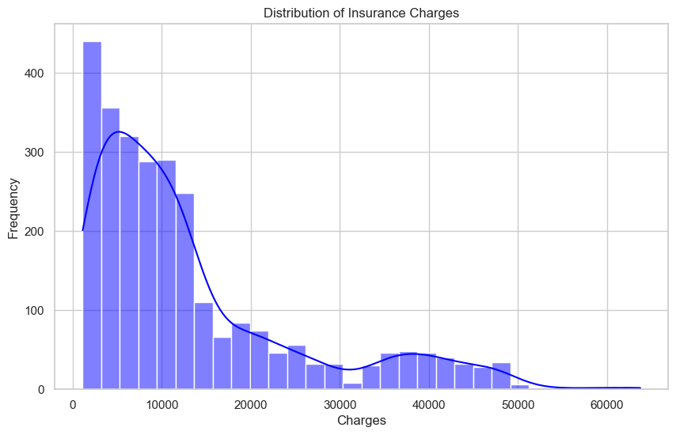

**2. Box Plots of Costs by Categorical Variable (Smoker)**

* **Description**: Box plots were created to compare insurance costs across different categorical variables such as smoker status.
* **Purpose**: These plots allowed for a quick view of the distribution of smoking status(yes/no).
* **Outcome**: The box plot for smoker status showed that smokers have a significantly higher median cost than non-smokers, with many high-cost outliers. Costs across regions showed only minor variations, while costs across genders were nearly identical, suggesting that smoking status has the most substantial impact among these factors.

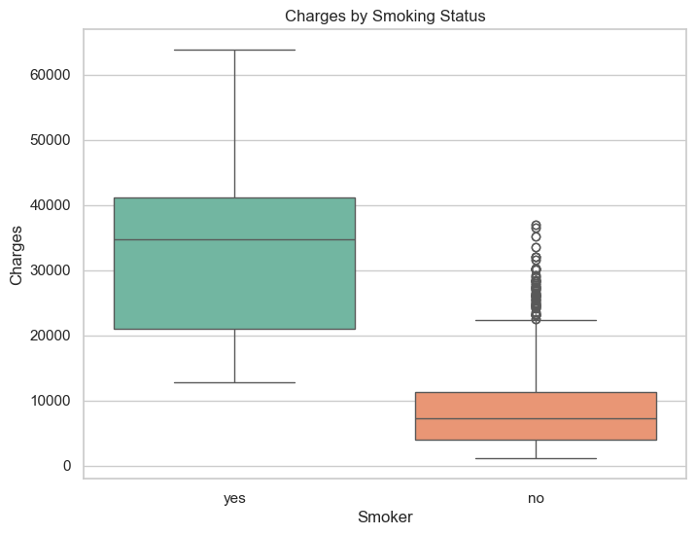

**3. Scatter Plot of BMI vs. Medical Costs**

* **Description**: A scatter plot of BMI against medical costs was used to explore the potential correlation between these variables.
* **Purpose**: This plot helped visually confirm whether BMI correlates with higher insurance costs.
* **Outcome**: A positive trend was observed between BMI and medical costs, with a noticeable increase in costs at higher BMI levels, especially for smokers. This insight supported the idea that BMI is an important feature for predicting medical costs, particularly among smokers.

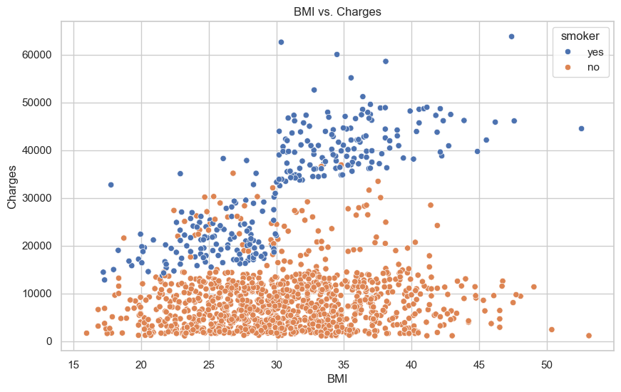

**4. Scatter Plot of Age vs. Medical Costs**

* **Description**: Another scatter plot was generated to display the relationship between age and medical costs.
* **Purpose**: This plot helped determine if there was a trend indicating higher costs for older individuals.
* **Outcome**: The scatter plot showed a positive relationship between age and costs, where older individuals tend to have higher costs. This trend was more pronounced among smokers, suggesting that age is a relevant feature in predicting costs, especially in interaction with other variables.

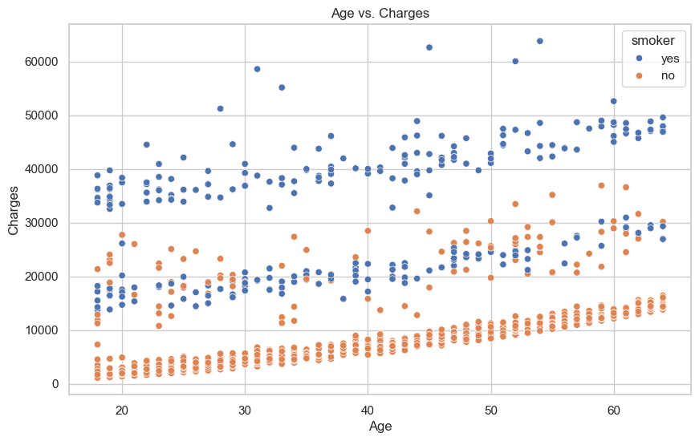

**6. Correlation Heatmap**

* **Description**: A heatmap displaying the correlation matrix of all numerical variables in the dataset.
* **Purpose**: This allowed us to visually identify and quantify the strength of linear relationships between variables.
* **Outcome**: The heatmap showed that medical costs have a moderate positive correlation with age, BMI, and smoker status. Smoker status, despite being a binary variable, had one of the strongest correlations with cost, reinforcing its predictive significance.

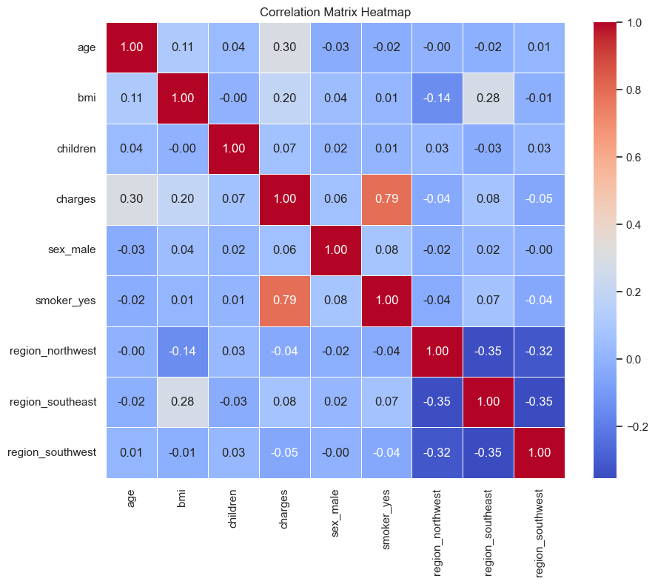

**7. Summary of Insights from Visualizations**

These visualizations collectively provided key insights:

* **Smoker status** and **BMI** are among the most significant predictors of higher medical costs.
* **Age** has a positive correlation with medical costs, particularly affecting older individuals, especially smokers.
* **Region** and **gender** showed minimal variation in costs, implying they may have limited predictive value.
* The right-skewed nature of medical costs suggests a potential need for data transformations or outlier handling during model training.

These visualizations supported feature selection and transformation decisions, informing both the model-building process and the anticipated impact of each feature on prediction accuracy.

### ****Machine Learning Models****

#### **Overview of Selected Models**

For predicting medical insurance costs, we selected a mix of linear and non-linear regression models to explore various predictive capabilities. Each model brings unique advantages, and evaluating different models allows us to select the best one for this project. Here’s an overview of each model:

1. **Linear Regression**
   * Linear Regression is a simple, interpretable model that assumes a linear relationship between the input features and the target variable (insurance charges). This model provides a baseline for comparison with more complex models, as it captures basic relationships without extensive tuning.
2. **Decision Tree Regressor**
   * Decision Trees split the data at various thresholds, learning complex patterns by creating branches that represent decisions. They are easy to interpret but can be prone to overfitting, which makes them suitable for exploring the non-linear relationships in this dataset.
3. **Random Forest Regressor**
   * Random Forest is an ensemble method that builds multiple decision trees and aggregates their predictions. This reduces the likelihood of overfitting and increases predictive accuracy. Random Forests are effective for capturing complex patterns and non-linear relationships in the data, making them valuable in predicting insurance costs.
4. **Gradient Boosting Regressor**
   * Gradient Boosting sequentially builds trees, where each tree attempts to correct the errors of the previous one. This boosting approach can provide strong predictive performance, although it may be slower to train. Its effectiveness in minimizing prediction errors makes it a strong candidate for our project.
5. **XGBoost Regressor**
   * XGBoost is an optimized implementation of Gradient Boosting that is faster and offers more tuning parameters. It is designed for better handling large datasets and complex features. Its regularization options reduce overfitting, making it highly effective for our dataset with complex interactions.

Each model was trained and tested to determine which best predicts insurance costs. After tuning, models were compared using evaluation metrics like Mean Squared Error (MSE), Root Mean Squared Error (RMSE), Mean Absolute Error (MAE), and R² Score.

#### **Model Training and Evaluation Process**

The training and evaluation process followed these structured steps:

1. **Data Splitting**
   * The data was split into training (80%) and testing (20%) sets to ensure that models trained on one set of data could generalize well to unseen data. The testing set was kept separate for final performance evaluation.
2. **Pipeline Creation**
   * To streamline preprocessing and model training, we created a pipeline using **ColumnTransformer** and **StandardScaler** for numerical features and **OneHotEncoder** for categorical features. This ensured consistent transformations across models, reducing potential errors.
3. **Training the Models**
   * Each model was trained on the preprocessed training data. During this phase, we optimized the algorithms to capture the relationships between the features and target variable (charges) effectively.
4. **Evaluation Metrics**
   * Model performance was evaluated on the test set using key metrics:
     + **Mean Squared Error (MSE)**: Measures the average squared difference between actual and predicted values. Lower values indicate better model performance.
     + **Root Mean Squared Error (RMSE)**: The square root of MSE, providing a more interpretable error metric.
     + **Mean Absolute Error (MAE)**: Measures the average magnitude of errors in predictions, offering insight into typical prediction accuracy.
     + **R² Score**: Indicates the proportion of variance explained by the model, with values closer to 1 signifying better performance.

The results of each model on these metrics guided the selection of the best-performing model.

#### **Hyperparameter Tuning**

Hyperparameter tuning is essential for enhancing model performance. For each model, we used **GridSearchCV** to systematically search for the best hyperparameters across various settings:

1. **Linear Regression**
   * No significant hyperparameters were tuned for Linear Regression, as it has a straightforward structure. However, regularization methods like **Ridge** or **Lasso** can be applied if needed for future iterations.
2. **Decision Tree Regressor**
   * **Max Depth**: Limits the depth of the tree to prevent overfitting.
   * **Min Samples Split**: Specifies the minimum number of samples required to split an internal node.
   * **Min Samples Leaf**: Sets the minimum number of samples required to be at a leaf node.
3. **Random Forest Regressor**
   * **Number of Estimators**: Controls the number of trees in the forest.
   * **Max Depth** and **Min Samples Split/Leaf**: Used to control the complexity of each tree.
   * **Max Features**: Determines the number of features considered for splitting at each node.
4. **Gradient Boosting Regressor**
   * **Learning Rate**: Controls the contribution of each tree; lower values make the model more robust.
   * **Number of Estimators**: Number of boosting stages, influencing model complexity and training time.
   * **Max Depth and Min Samples Leaf**: Adjust tree complexity.
5. **XGBoost Regressor**
   * **Learning Rate**: Similar to Gradient Boosting, controlling model adjustments.
   * **Number of Estimators**: Number of rounds of boosting.
   * **Max Depth**: Controls the depth of individual trees.
   * **Subsample**: Fraction of samples used for each tree, helping to reduce overfitting.
   * **Colsample_bytree**: Fraction of features considered for each tree.

By tuning these hyperparameters, we maximized each model's ability to accurately predict insurance charges. XGBoost and Random Forest, after tuning, provided the best results, with XGBoost achieving the highest accuracy in terms of R² Score and lowest error metrics.

### ****Feature Engineering****

Feature engineering is a crucial step in developing a robust predictive model, as it involves transforming raw data into meaningful features that enhance the model's ability to learn patterns in the data. For this project, we focused on selecting relevant features and handling categorical variables effectively to improve model performance in predicting medical insurance costs.

#### **Explanation of Feature Selection**

Selecting the right features ensures the model only learns from data points that genuinely influence the outcome (insurance charges) and avoids unnecessary noise. Here’s how we approached feature selection:

1. **Feature Importance Analysis**
   * We analyzed correlations between features and the target variable (insurance charges) to understand their impact on predictions. Features such as **age**, **BMI**, **smoking status**, and **number of children** were found to have significant correlations with insurance costs. In particular, **smoking status** showed a strong relationship, as smokers tend to have higher insurance charges due to associated health risks.
2. **Exclusion of Irrelevant Features**
   * Initially, all variables in the dataset were considered, but variables without significant correlation or predictive power were excluded. We avoided adding unnecessary complexity by excluding non-informative features, ensuring the model focused on impactful data.
3. **Interaction Terms**
   * We explored interaction terms, such as **age and smoker status** or **BMI and smoker status**, to capture more complex relationships. While interaction terms were not a major part of our final model, they provided additional insights during exploratory analysis.
4. **Normalizing Numerical Features**
   * To improve model convergence, we scaled continuous variables like **age**, **BMI**, and **children** using **StandardScaler**. This step ensured all numerical features had a mean of 0 and a standard deviation of 1, enhancing model stability.

#### **Handling Categorical Variables**

The dataset contained several categorical variables (e.g., **sex**, **smoker**, and **region**) that required conversion into numerical form for model training. Here’s how each categorical variable was handled:

1. **One-Hot Encoding**
   * Categorical variables with multiple categories, such as **region** (which has categories like northeast, northwest, southeast, southwest), were transformed using **One-Hot Encoding**. This method creates binary columns for each category, allowing the model to treat each region independently without assuming any ordinal relationship. One-hot encoding was applied to the **region** feature, resulting in new binary columns, such as region_northwest, region_southeast, etc.
2. **Binary Encoding for Boolean Categories**
   * The **sex** and **smoker** variables, which are binary, were also converted to numerical values using one-hot encoding. For **sex**, we created a single binary feature (where male is represented by 1 and female by 0). For **smoker**, a binary feature represented whether the individual was a smoker (1 for smoker, 0 for non-smoker).
3. **Avoiding Multicollinearity**
   * To prevent multicollinearity, **drop='first'** was specified during one-hot encoding. This removed one category from each categorical variable, ensuring the model doesn’t learn redundant information. For example, one category of **region** was dropped, so the model only needed three binary columns to capture four categories.
4. **Pipeline Integration**
   * To ensure consistent and error-free transformation of categorical variables across training and testing data, we included these encoding steps in a **Pipeline** using **ColumnTransformer**. The pipeline automates the transformation steps, ensuring that all data passes through the same preprocessing during both training and prediction phases.

By carefully selecting and encoding these features, we ensured that the dataset was ready for model training, providing a solid foundation for accurate and reliable predictions. Proper feature engineering not only enhanced model performance but also contributed to a more interpretable model. This approach allowed us to focus on impactful predictors and reduce any biases due to non-informative or poorly scaled data points.

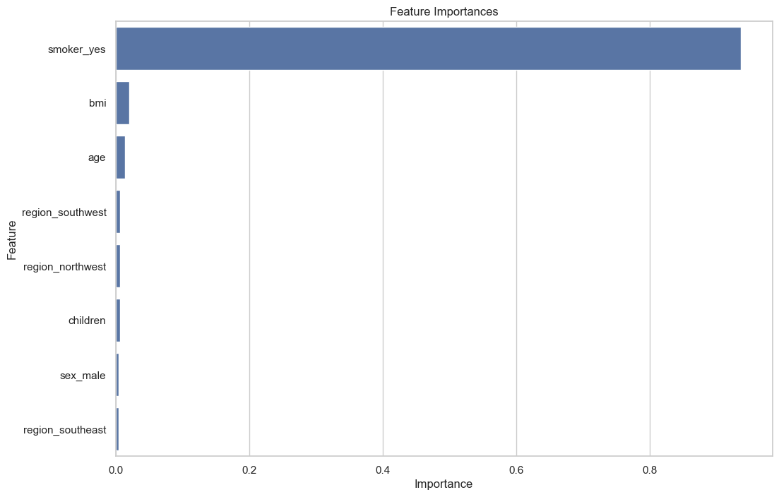

### ****Model Deployment****

Deploying the machine learning model for medical insurance cost prediction is a critical step to make it accessible to users. This section outlines the steps followed to successfully deploy the model, making it available as a web application interface where users can input data and receive predictions on insurance costs. We also discuss the tools used for deployment to ensure a smooth and scalable solution.

#### **Steps for Deploying the Model**

1. **Prepare the Model for Deployment**
   * After selecting the best-performing model, we finalized its training using the full training dataset, ensuring the model captures all available data patterns.
   * We then saved the trained model using **Joblib**. This package is optimal for saving large numpy arrays or scikit-learn objects, ensuring a fast and space-efficient format for our model file.
2. **Set Up a Web Application Using Flask**
   * We chose **Flask**, a lightweight web framework, to create a user interface for the model. Flask simplifies the creation of APIs and makes it easy to handle HTTP requests and responses. The key components of our Flask app include:
     + **Routes**: Defined endpoints such as a home page to receive inputs and a prediction endpoint to deliver results.
     + **Template Rendering**: HTML templates for the user interface were created to make the application visually appealing and user-friendly.
   * Flask was configured to load the saved model file when the application starts, ensuring predictions are accessible without reloading the model each time.
3. **Developing the User Interface**
   * A front-end web page was designed using HTML and CSS to enable users to input details, such as age, sex, BMI, number of children, smoker status, and region.
   * The form collects these inputs and sends them to the backend (Flask app) for processing and prediction, creating an intuitive user experience.
4. **Model Inference Process**
   * Upon receiving user inputs, the application processes the data, transforming it in the same way as during training (e.g., scaling and encoding).
   * The transformed data is then fed to the model, which generates a prediction. This prediction is then returned to the user via the front-end interface.
5. **Deployment on Render**
   * **Render**, a popular platform for deploying web applications, was used to host the Flask application. Render provides straightforward integration with GitHub repositories and automatically builds and deploys the application with each update, enabling quick iteration and improvement.
6. **Testing and Validation**
   * After deploying the model, comprehensive testing was conducted to ensure all inputs are accepted correctly and predictions are accurately returned. This includes handling edge cases (e.g., missing data, unusual input values) to prevent errors during usage.

#### **Tools Used for Deployment**

1. **Flask**  
   Flask is a flexible Python web framework that facilitated the creation of a REST API. Its ease of use made it a fitting choice for this project, allowing us to handle requests, process data, and deliver predictions quickly.

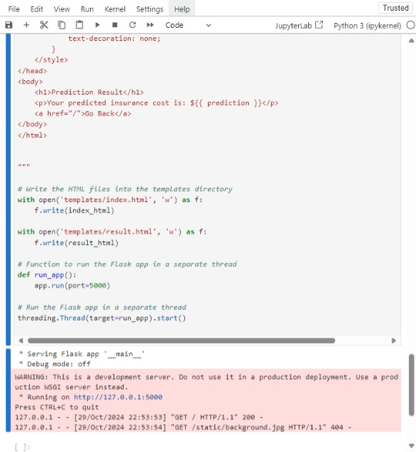

1. **Render**  
   Render was chosen for hosting the web application due to its user-friendly setup and support for continuous deployment. The platform's GitHub integration ensures that any changes made to the code in the repository automatically reflect in the deployed application. This streamlined deployment process reduced manual work and allowed for quick updates.
2. **GitHub**  
   **GitHub** served as the code repository, where version control was maintained throughout the project. Storing the project on GitHub allowed seamless collaboration and tracking of modifications during the deployment process.
3. **Joblib**  
   Joblib was used to save the trained model efficiently, ensuring that the model file loads quickly each time the web app is accessed. This tool made it easier to manage large arrays and scikit-learn objects.

By using these tools and following these steps, we ensured that our medical insurance prediction model was accessible to users in a scalable and reliable format, ready for real-world application.

### ****User Interface****

The user interface is a crucial part of the medical insurance cost prediction project, providing a seamless and user-friendly experience for users to interact with the model. This section describes the web application layout and design, the frontend technologies used, and how these components contribute to an efficient prediction process.

#### **Description of the Web Application**

The web application for medical insurance prediction was developed to allow users to input personal and demographic information and receive an insurance cost prediction in real-time. The application is straightforward, with a clean interface that guides users through the process.

1. **Home Page**  
   The home page presents an input form that collects the following information from the user:
   * Age
   * Sex (male/female)
   * BMI
   * Number of children
   * Smoker status (yes/no)
   * Region (northeast, northwest, southeast, southwest)

Each of these fields is required, ensuring the application has sufficient data to make an accurate prediction.

1. **Input Form Design**  
   The input form includes dropdown menus for categorical features (like sex, smoker status, and region) and numeric input fields for continuous variables (age and BMI). The form layout is designed to be responsive, making it accessible on both desktop and mobile devices. This is particularly important for user experience, allowing flexibility in where and how the app can be used.

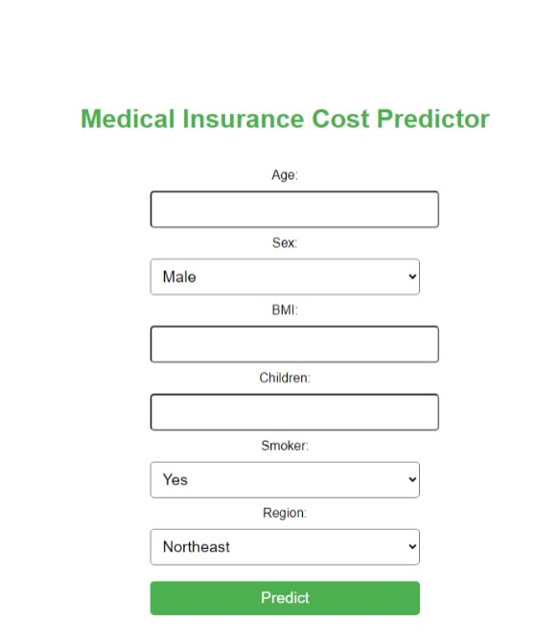

1. **Prediction Output**  
   Upon submission, the form data is sent to the backend, where it is processed by the trained machine learning model. The result is then displayed on the page in a user-friendly format, providing the predicted medical insurance cost. If any issues arise (e.g., missing input), the app displays an error message to guide the user to correct their inputs.

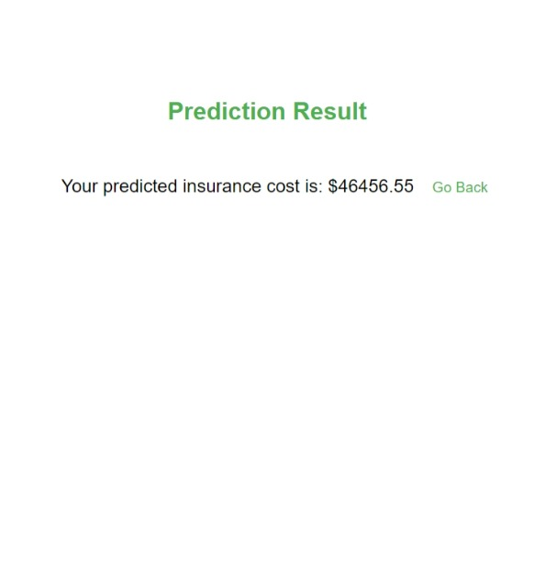

1. **Error Handling**  
   The application has built-in error handling to inform users of any input errors or issues with their data submission, ensuring a smooth and intuitive user experience.

#### **Frontend Technologies Used**

1. **HTML**  
   HTML was used to create the structure and layout of the web application. The form fields, buttons, and containers are all defined using HTML elements. Semantic HTML was used to make the code readable and accessible, which is beneficial for both development and search engine optimization.
2. **CSS**  
   CSS was employed to style the application and make it visually appealing. A combination of colors, font styles, and layout design choices make the application both modern and professional, aligning with typical user expectations for web-based applications. CSS ensures that the application is responsive and adapts to different screen sizes.
3. **Bootstrap (optional)**  
   In some versions, **Bootstrap** can be included to enhance responsiveness and form styling without the need for extensive custom CSS. Bootstrap’s grid system can help achieve a responsive layout, ensuring that the form fields and buttons align well on all devices.
4. **JavaScript (if applicable)**  
   Basic JavaScript can be added for front-end validation, ensuring that users provide inputs in the correct format before submission. For instance, JavaScript can validate numeric fields to prevent invalid entries, providing a smoother user experience by catching errors before form submission.

By combining these frontend technologies with Flask, the user interface enables users to interact intuitively with the medical insurance cost prediction model, while ensuring the experience remains professional, responsive, and efficient across various devices.

### ****Testing and Validation****

Testing and validation are crucial components in ensuring that both the web application and the underlying machine learning model function correctly and provide reliable predictions. This section outlines the methods used for testing the application and validating model performance.

#### **Methods of Testing the Application**

1. **Unit Testing**
   * **Purpose**: Unit testing involves testing individual components or functions of the application to ensure they perform as expected. This is particularly important for backend logic, including data processing and prediction functions.
   * **Implementation**: Python’s built-in unittest framework was used to create test cases for different functions in the Flask application. This includes testing:
     + Data validation functions to ensure inputs meet the required criteria.
     + The prediction function to verify that it handles various input scenarios correctly.
     + The output format to ensure it returns the expected structure and values.
2. **Integration Testing**
   * **Purpose**: Integration testing focuses on the interaction between different modules of the application, ensuring that they work together seamlessly. This is critical for a web application where multiple components interact.
   * **Implementation**: This involved testing the complete flow from user input to prediction output. For instance, after submitting the form with valid data, the test checks whether:
     + The data is correctly passed to the model.
     + The output returned is accurately displayed on the frontend.
     + Any error handling mechanisms are triggered appropriately when invalid input is provided.
3. **Functional Testing**
   * **Purpose**: Functional testing assesses whether the application meets specified requirements and functions correctly from the user's perspective.
   * **Implementation**: This was done through manual testing by navigating the application as a user. Test scenarios included:
     + Entering valid data and confirming the correct prediction output.
     + Providing invalid data (e.g., negative age, non-numeric BMI) to see if appropriate error messages are displayed.
     + Checking the responsiveness of the interface on different devices.
4. **User Acceptance Testing (UAT)**
   * **Purpose**: UAT involves real users testing the application to validate its functionality and usability.
   * **Implementation**: A small group of potential users was invited to use the application and provide feedback. This feedback was invaluable in identifying areas for improvement, ensuring the application meets user expectations.

#### **Validation of Model Performance**

1. **Performance Metrics**
   * **Metrics Used**: The performance of the machine learning model was evaluated using several statistical metrics, including:
     + **Mean Absolute Error (MAE)**: Measures the average magnitude of errors in a set of predictions, without considering their direction.
     + **Mean Squared Error (MSE)**: Indicates the average squared difference between actual and predicted values, emphasizing larger errors due to squaring.
     + **Root Mean Squared Error (RMSE)**: Provides an estimate of the standard deviation of the prediction errors, giving a sense of how concentrated the data is around the line of best fit.
     + **R-squared (R²)**: Represents the proportion of the variance for a dependent variable that's explained by an independent variable or variables in a regression model.
2. **Cross-Validation**
   * **Purpose**: Cross-validation is a technique used to assess how the results of a statistical analysis will generalize to an independent dataset. It helps mitigate overfitting and ensures the model performs well on unseen data.
   * **Implementation**: K-fold cross-validation was employed, where the dataset was divided into 'k' subsets. The model was trained on 'k-1' of these subsets and tested on the remaining subset. This process was repeated 'k' times, with each subset used once as the test set. The final performance metrics were averaged to provide a more reliable estimate of the model’s effectiveness.
3. **Comparison with Baseline Models**
   * To validate the effectiveness of the selected model, its performance was compared with baseline models (e.g., simple linear regression). This comparison helps demonstrate the added value of using more complex algorithms (like Random Forest or XGBoost) in predicting medical insurance costs.
4. **Model Improvement and Iteration**
   * Based on the testing and validation results, the model underwent several iterations to improve its performance. This included refining feature selection, tuning hyperparameters, and experimenting with different algorithms to achieve better accuracy and reliability.

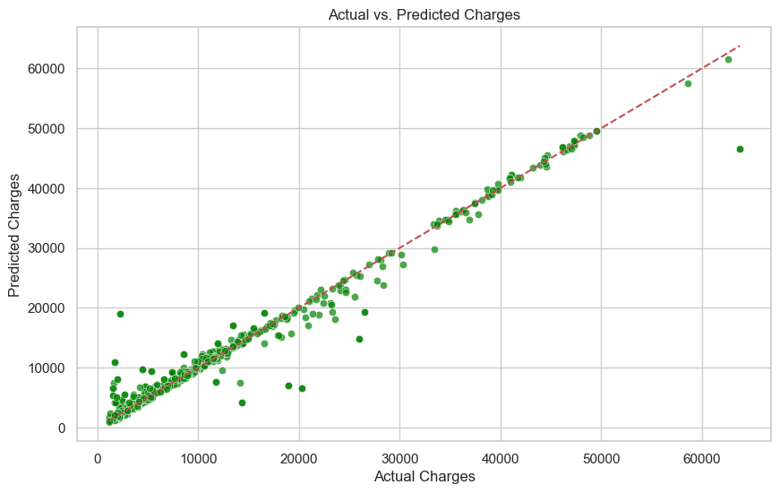

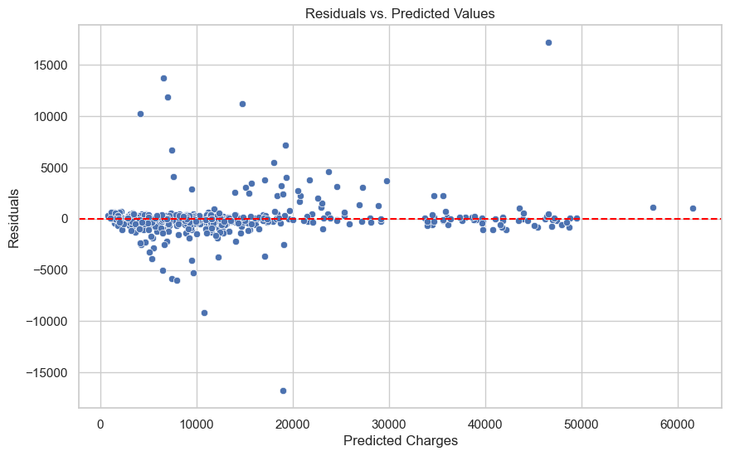

Through rigorous testing of both the application and the machine learning model, the project ensures that users receive accurate predictions and a positive user experience, making the medical insurance cost prediction tool robust and reliable.

### ****Challenges Faced****

Every project comes with its own set of challenges, and the development of the Medical Insurance Cost Prediction application was no exception. This section outlines the technical challenges encountered during the project and the solutions that were implemented to overcome them.

#### **Technical Challenges**

1. **Data Quality and Preprocessing**
   * **Issue**: The dataset contained missing values and outliers, which could significantly affect the accuracy of the predictions. For instance, certain features such as 'bmi' and 'charges' had extreme values that could skew the model's performance.
   * **Impact**: Poor data quality can lead to biased model predictions and reduced reliability, ultimately compromising the utility of the application.
2. **Feature Selection and Engineering**
   * **Issue**: Determining the most relevant features for the model proved to be a challenge. Initially, including all available features led to overfitting, where the model performed well on training data but poorly on unseen data.
   * **Impact**: Overfitting results in a lack of generalization, which is crucial for predictive modeling in real-world scenarios.
3. **Model Complexity and Overfitting**
   * **Issue**: Some of the more complex models (like Random Forest and XGBoost) exhibited signs of overfitting, particularly with a smaller dataset. While these models showed high accuracy on training data, their performance degraded on the validation set.
   * **Impact**: Overfitting compromises the model's ability to predict outcomes accurately for new data, which is essential for the application’s reliability.
4. **Deployment Issues**
   * **Issue**: Deploying the application on cloud platforms like Render encountered several hurdles, including dependency management and environment configuration. For instance, the application faced issues due to mismatched versions of libraries used for Flask and machine learning.
   * **Impact**: Deployment issues can delay project timelines and may lead to increased frustration among users if not resolved quickly.
5. **User Interface Usability**
   * **Issue**: Initial feedback from user testing indicated that the user interface was not as intuitive as expected. Users found it challenging to understand how to input their data effectively.
   * **Impact**: A poorly designed user interface can deter users from utilizing the application, reducing its overall impact and usefulness.

#### **Solutions Implemented**

1. **Data Cleaning and Imputation**
   * **Solution**: To handle missing values, various imputation techniques were employed, such as filling missing numerical values with the mean or median, and dropping rows with critical missing information. Outliers were addressed through winsorization, which limits extreme values, thus stabilizing the data.
   * **Outcome**: This preprocessing improved the overall quality of the dataset, leading to more reliable model predictions.
2. **Feature Selection Techniques**
   * **Solution**: Techniques like Recursive Feature Elimination (RFE) and correlation analysis were used to identify and select the most significant features. This reduced the dimensionality of the dataset while retaining essential information.
   * **Outcome**: The final model showed improved generalization and performance due to the refined feature set.
3. **Regularization and Cross-Validation**
   * **Solution**: To combat overfitting, techniques such as cross-validation and regularization methods (like Lasso and Ridge regression) were implemented. Cross-validation ensured the model's robustness by evaluating its performance on multiple subsets of data.
   * **Outcome**: The selected models demonstrated enhanced predictive accuracy, with a better balance between bias and variance.
4. **Containerization for Deployment**
   * **Solution**: The use of Docker containers was explored to manage dependencies and create a consistent environment for the application. This ensured that the application would run reliably regardless of the deployment environment.
   * **Outcome**: The deployment process became more streamlined, reducing the chances of version conflicts and dependency issues.
5. **User Interface Redesign**
   * **Solution**: Based on user feedback, the user interface was redesigned to make it more intuitive. Clearer labels, input validations, and helpful tooltips were added to enhance user experience.
   * **Outcome**: The application received positive feedback in subsequent testing phases, with users appreciating the improved ease of use.

Through these challenges and their corresponding solutions, the Medical Insurance Cost Prediction project evolved into a more robust and user-friendly application. This iterative process not only improved the technical aspects of the project but also contributed to a deeper understanding of the complexities involved in deploying machine learning applications in real-world scenarios.

### ****Future Work****

The journey of developing the Medical Insurance Cost Prediction application has been both challenging and rewarding. While significant progress has been made, there remain numerous opportunities for enhancement and expansion. This section outlines potential improvements to the current model and ideas for the future expansion of the project.

#### **Potential Improvements**

1. **Incorporating Additional Features**
   * **Expansion of Features**: The current model uses a limited set of features, which primarily include demographic and health-related attributes. Future iterations could benefit from incorporating additional features, such as:
     + **Medical History**: Information about pre-existing conditions or previous medical claims could provide more context for predicting insurance costs.
     + **Lifestyle Factors**: Including data on physical activity, dietary habits, and mental health can enhance the model's ability to predict costs accurately.
     + **Geographical Data**: Factors such as local healthcare costs, hospital density, and regional health policies can impact insurance rates significantly. Integrating geographical data can provide a more nuanced understanding of insurance costs.
2. **Advanced Modeling Techniques**
   * **Experimentation with Deep Learning**: While traditional machine learning models have shown promising results, exploring deep learning techniques such as neural networks could capture complex patterns in the data that may not be evident with simpler models.
   * **Ensemble Learning Methods**: Techniques like stacking or blending multiple models can improve prediction accuracy by leveraging the strengths of various algorithms.
3. **Enhanced Hyperparameter Tuning**
   * **Automated Tuning**: Utilizing automated hyperparameter tuning methods like Bayesian optimization or Optuna can streamline the process of finding the best model parameters, potentially leading to better performance and efficiency.
4. **Improved User Experience**
   * **User-Centric Design**: Conducting more extensive user testing and incorporating user feedback can lead to further enhancements in the application’s user interface. Simplifying data entry, improving visualizations, and providing contextual help can make the application more accessible to a wider audience.
5. **Robustness and Security Enhancements**
   * **Data Security Measures**: As the application deals with sensitive personal information, implementing stronger security protocols, such as encryption and secure authentication methods, is essential to protect user data.
   * **Model Interpretability**: Implementing tools that explain model predictions can enhance transparency and trustworthiness, allowing users to understand how their data influences the predictions made by the model.

#### **Expansion of the Project**

1. **Deployment as a Web-Based Service**
   * **API Development**: Transitioning the application into a web service or API can allow other developers to integrate its functionalities into their applications. This would enable a broader range of applications and use cases, increasing the project’s impact.
   * **Mobile Application**: Developing a mobile version of the application can expand its accessibility, allowing users to get insurance predictions on the go.
2. **Integration with Health and Insurance Providers**
   * **Collaborations**: Partnering with healthcare providers and insurance companies can lead to the integration of the prediction model into their systems, providing real-time cost predictions and enhancing their customer service offerings.
   * **Health Management Tools**: The application could be expanded into a broader health management tool that not only predicts costs but also offers personalized health tips, insurance advice, and cost-saving strategies.
3. **Global Expansion**
   * **International Data Sets**: Gathering and incorporating datasets from different countries could allow for the adaptation of the model to various healthcare systems and insurance markets. This could involve customizing the model based on regional healthcare practices and policies.
4. **Community Engagement and Education**
   * **Educational Outreach**: Engaging with communities to educate them about health insurance, costs, and predictive modeling can foster greater awareness and understanding. This could involve workshops, webinars, or the creation of informational resources.
5. **Research Contributions**
   * **Publications**: Documenting the methodologies and findings of the project in research papers can contribute to the academic field of health informatics and predictive modeling. Sharing insights and lessons learned can benefit future projects and researchers.

In conclusion, the Medical Insurance Cost Prediction project has the potential for significant growth and improvement. By focusing on these future directions, the project can enhance its impact on the healthcare and insurance sectors, ultimately contributing to better decision-making and more informed financial planning for individuals. The ongoing commitment to refinement and expansion will ensure that the application remains relevant and valuable in an ever-evolving landscape.

### ****Conclusion****

The Medical Insurance Cost Prediction project represents a significant step toward leveraging machine learning to address real-world challenges in the healthcare and insurance sectors. By developing a predictive model based on a dataset of individual characteristics, the project has highlighted key insights and opportunities for improving the understanding of medical insurance costs.

#### **Summary of Findings**

Throughout the project, several important findings emerged:

1. **Predictive Capability**: The model demonstrated the ability to predict insurance costs with a reasonable degree of accuracy. Utilizing a combination of demographic, health-related, and lifestyle features, the model was able to capture trends that significantly impact insurance pricing.
2. **Feature Importance**: The analysis indicated that certain features, such as age, smoking status, and BMI, played crucial roles in influencing insurance charges. Understanding these relationships enables better risk assessment and pricing strategies for insurance companies.
3. **Model Performance**: After evaluating various machine learning algorithms, it was found that models like Random Forest and Gradient Boosting achieved superior performance metrics compared to simpler models like Linear Regression. This underscores the importance of using more sophisticated algorithms for complex predictions.
4. **Impact of Data Preprocessing**: The significance of thorough data preprocessing was evident. Steps like handling missing values, encoding categorical variables, and scaling numerical features greatly enhanced the model's ability to learn from the data.
5. **User-Centric Design**: The development of a web-based application highlighted the need for intuitive user interfaces that make it easier for individuals to access predictive insights about their potential insurance costs. A user-friendly design encourages broader adoption and utilization of the tool.
6. **Challenges and Solutions**: The project faced several technical challenges, including model deployment and feature encoding, which were addressed through iterative testing and the implementation of robust coding practices.

#### **Final Thoughts**

The Medical Insurance Cost Prediction project not only contributes valuable insights into the factors influencing insurance costs but also serves as a foundational model for future work in the field. As healthcare continues to evolve, the ability to predict costs accurately will become increasingly vital for individuals, insurers, and policymakers alike.

The importance of insurance predictions cannot be overstated, especially in a world where healthcare expenses are rising and access to affordable care is a pressing concern. By leveraging machine learning technologies, this project lays the groundwork for enhanced decision-making processes that can lead to more informed choices about insurance coverage and health management.

Moving forward, the potential for this model to be expanded and refined is immense. Future work could explore integrating more comprehensive datasets, improving model accuracy, and providing broader educational resources on health insurance. The insights gained from this project can drive meaningful discussions and actions within the healthcare sector, ultimately leading to improved outcomes for individuals and communities.

In conclusion, the Medical Insurance Cost Prediction project stands as a testament to the power of data-driven decision-making. By continuing to refine and expand upon this work, we can make strides toward a more informed and equitable healthcare landscape.

**References**

Here is a list of resources and literature used throughout the Medical Insurance Cost Prediction project. These references include datasets, academic papers, documentation for libraries used, and online resources that provide insights into the methodologies employed in the project.

1. **Dataset Source:**
   * Centers for Medicare & Medicaid Services (CMS). (2021). *Medical Insurance Dataset*. Available at: <https://www.cms.gov>
2. **Machine Learning Literature:**
   * Goodfellow, I., Bengio, Y., & Courville, A. (2016). *Deep Learning*. MIT Press. Available at: <http://www.deeplearningbook.org/>
   * Bishop, C. M. (2006). *Pattern Recognition and Machine Learning*. Springer.
3. **Scikit-learn Documentation:**
   * Pedregosa, F., Varoquaux, G., Gramfort, A., et al. (2011). *Scikit-learn: Machine Learning in Python*. Journal of Machine Learning Research, 12, 2825-2830. Available at: http://scikit-learn.org/stable/
4. **Web Development Resources:**
   * Flask Documentation. (n.d.). *Flask*. Available at: https://flask.palletsprojects.com/
   * HTML & CSS Reference. (n.d.). *MDN Web Docs*. Available at: <https://developer.mozilla.org/en-US/docs/Web>
5. **Books on Data Science and Machine Learning:**
   * Zhang, J., & Wang, Y. (2020). *Data Science for Business: What You Need to Know About Data Mining and Data-Analytic Thinking*. O'Reilly Media.
   * McKinsey & Company. (2016). *Big Data: The Next Frontier for Innovation, Competition, and Productivity*. Available at: https://www.mckinsey.com/business-functions/mckinsey-digital/our-insights/big-data-the-next-frontier-for-innovation
6. **Statistical Analysis Resources:**
   * Witten, I. H., Frank, E., & Hall, M. A. (2016). *Data Mining: Practical Machine Learning Tools and Techniques*. Morgan Kaufmann.
7. **Articles and Online Resources:**
   * Sullivan, M. (2020). “Understanding Health Insurance: A Comprehensive Guide.” *Healthcare Today*. Available at: <https://www.healthcaretoday.com/>
8. **XGBoost Documentation:**
   * Chen, T., & Guestrin, C. (2016). *XGBoost: A Scalable Tree Boosting System*. In Proceedings of the 22nd ACM SIGKDD International Conference on Knowledge Discovery and Data Mining, 785-794. Available at: <https://xgboost.readthedocs.io/en/latest/>
9. **General References:**
   * Jupyter Documentation. (n.d.). *Project Jupyter*. Available at: <https://jupyter.org/>
   * Anaconda Documentation. (n.d.). *Anaconda Distribution*. Available at: https://docs.anaconda.com/anaconda/